**Supplementary Material**

**Table 1.** Statistics for linear regression models comparing hydrological metrics with intraspecific variation in wood density for the three most common species in the study. Significant results are shown in italics.

|  |  |  |  |  |  |  |
| --- | --- | --- | --- | --- | --- | --- |
|  | *Acacia dealbata* | | *Tristaniopsis laurina* | | *Casuarina cunninghamiana* | |
|  | p | R2 | p | R2 | p | R2 |
| MDFAnnZer | NA | 0.00 | *0.015* | *0.9994* | 0.176 | 0.51 |
| MDFAnnUnder0.1 | NA | 0.00 | *0.016* | *0.9994* | 0.388 | 0.25 |
| MDFAnnHSNum | 0.114 | 0.79 | 0.235 | 0.87 | 0.612 | 0.10 |
| CVAnnHSNum | 0.055 | 0.89 | 0.209 | 0.90 | 0.501 | 0.16 |
| CVAnnHSPeak | 0.098 | 0.81 | 0.445 | 0.59 | 0.531 | 0.14 |
| LSMeanDur | 0.656 | 0.12 | 0.443 | 0.59 | 0.796 | 0.03 |
| MDFAnnLSNum | 0.602 | 0.16 | 0.287 | 0.81 | 0.914 | 0.00 |
| CVAnnLSNum | 0.819 | 0.03 | 0.639 | 0.29 | 0.715 | 0.05 |
| CVAnnLSPeak | 0.581 | 0.18 | 0.096 | 0.98 | 0.574 | 0.12 |
| CVAnnLSMeanDur | 0.488 | 0.26 | 0.641 | 0.29 | 0.100 | 0.65 |
| CVAnnMRateRise | 0.906 | 0.01 | 0.458 | 0.57 | 0.117 | 0.61 |
| CVAnnMRateFall | 0.232 | 0.59 | 0.260 | 0.84 | 0.221 | 0.44 |
| BFI | 0.815 | 0.03 | 0.365 | 0.71 | 0.115 | 0.62 |
| CVAnnBFI | 0.539 | 0.21 | 0.773 | 0.12 | *0.003* | *0.96* |
| C_MDFM | 0.713 | 0.08 | 0.382 | 0.68 | 0.330 | 0.31 |
| M_MDFM | 0.262 | 0.54 | 0.550 | 0.42 | *0.033* | *0.83* |
| C_MinM | 0.715 | 0.08 | 0.201 | 0.90 | 0.386 | 0.25 |
| M_MinM | 0.276 | 0.52 | 0.912 | 0.02 | 0.192 | 0.48 |
| HSPeaknorm | 0.677 | 0.10 | 0.431 | 0.61 | 0.449 | 0.20 |
| LSPeaknorm | 0.867 | 0.02 | 0.430 | 0.61 | 0.475 | 0.18 |
| MRateRisenorm | *0.0001* | *0.9998* | 0.153 | 0.94 | *0.017* | *0.88* |
| MRateFallnorm | 0.094 | 0.82 | 0.165 | 0.93 | 0.162 | 0.53 |
| MA.7daysMinMeannorm | 0.869 | 0.02 | 0.337 | 0.75 | 0.548 | 0.13 |
| AS20YrARInorm | 0.256 | 0.55 | 0.120 | 0.96 | 0.084 | 0.68 |

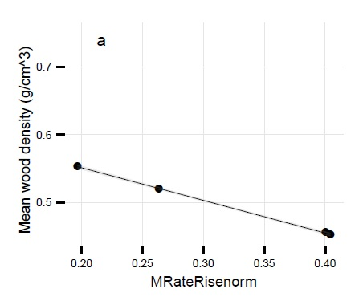

**Figure 1.** Relationship between wood density of Acacia dealbata and normalised mean flood rise rate (MRateRisenorm). Shaded areas depict the 95% confidence interval around the regression model.

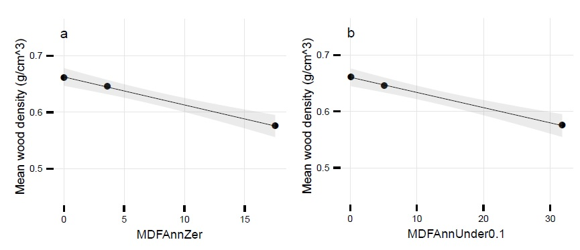

**Figure 2.** Relationships between wood density of Tristaniopsis laurina and hydrological metrics describing a.) mean annual frequency of zero flow days (MDFAnnZer) b.) mean annual frequency of days with flow under 0.1 ML/day (MDFAnnUnder0.1). Shaded areas depict the 95% confidence interval around the regression model.

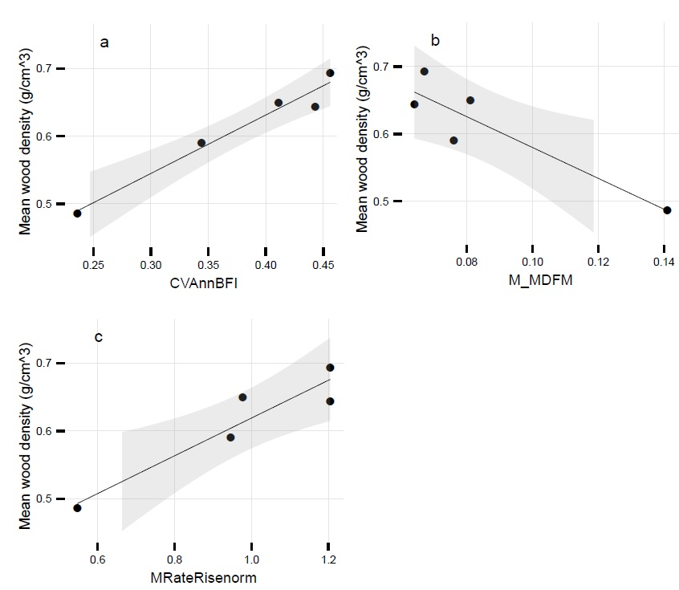

Figure 3 Relationships between wood density of Casuarina cunninghamiana and hydrological metrics describing a.) interannual variability in baseflow index (CVAnnBFI), b.) contingency of monthly mean daily flow (M_MDFM), c.) normalised mean flood rise rate (MRateRisenorm). Shaded areas depict the 95% confidence interval around the regression model.